NGPF Activity Bank

Checking #9
INTERACTIVE: Navigate Your Online Bank Account (Extended Version) [Answer Key]

Interactive: NGPF OnlineBank Simulation

- Teacher Tip: We recommend implementing this activity by putting the slides up on a projector and walking students through the different steps as a whole class. This is so that students only have to navigate between 2 tabs on their browser - the worksheet and the bank simulator - and to create a cohesive experience for all students in the classroom. An alternative idea is to print the worksheet and have the students navigate between the slides and bank simulator on their browser.
- Teacher Tip: If you need your student to completely start over on the simulation once they’ve already started, and you want them to start from scratch, they can click their username at the top right and push “RESET ALL.”
- Teacher Tip: In order for the students to have the same experience, they will each need to answer question #5 with “MONTHLY.” It is worth discussing the pros/cons of MONTHLY vs. SINGLE payments but they should all select MONTHLY to ensure consistency across all students.
- Teacher Tip: If every student follows all directions precisely, they’ll all end up with the same results. If a student or two (or more) gets off-track, it can sometimes be very time consuming to figure out where they went astray. One teacher who’s used the simulation suggests telling those who “messed up” their account to just partner with someone who has the correct end balance to complete Parts IX through the end.

Answer the questions in this worksheet as you go through the Navigate Your Online Bank Account slides.

Part I: Set Up Your Online Account
Follow the directions in Steps 2 and 3 on the slides.

Part II: Let’s Pay Some Bills
Follow the directions for Steps 4-7 on the slides.

Bill #1:
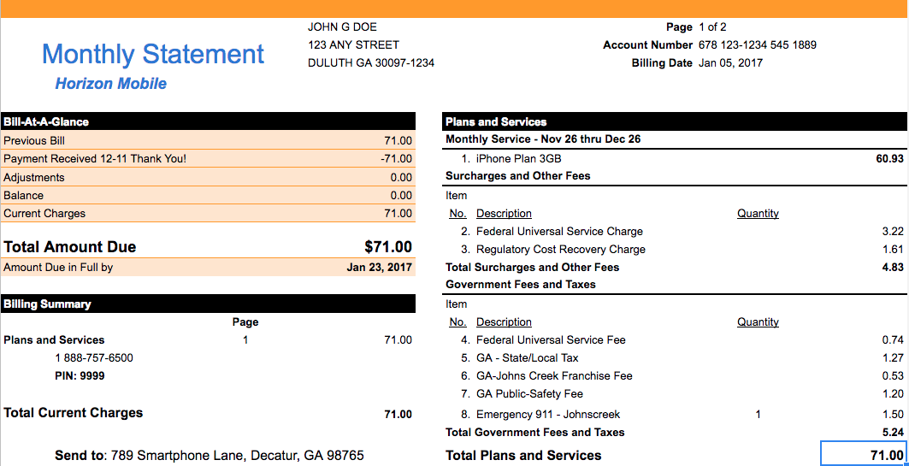
- Look at the due date on the bill above. When will you schedule this payment in order for your payment to be received on time by Horizon? Explain.
According to the bill, it is due by January 23rd, 2017. The payment date in your online bill pay is the date that the money will be taken out of your account, NOT the date that it will be received by the vendor. The intent of this question is to get students to make a prediction on when to send the payment. They will discover the answer in question #2.

**Head back to your slides now**

- Observe the pop-up after submitting your payment. Will your payment be there on time?
After your students pay the bill, they will see this message “It will take 4-6 business days to process this request.” They will need to schedule this bill at least 8 days prior (4-6 business days + any weekends if applicable) OR SOONER. Otherwise, it may not arrive on time.

- What will happen if the information you add about the cell phone company during this process is incorrect (e.g., address or zip code)?
The bill will not be received on time by the cell phone company which will likely result in late payment fees and, if it continues month after month, will likely result in the account being shut down.

- What is one potential problem with selecting MONTHLY for payment frequency?
When the student selects MONTHLY, the bank makes this $71 payment automatically. Two potential problems that could arise:
- The amount owed changes one month for some reason and so the student pays too much/too little. If too little, this could lead to interest charges and late fees.
- The student doesn’t keep up on their account balances and overdraws their account since this payment is made automatically.

**Head back to your slides now**

Bill #2:
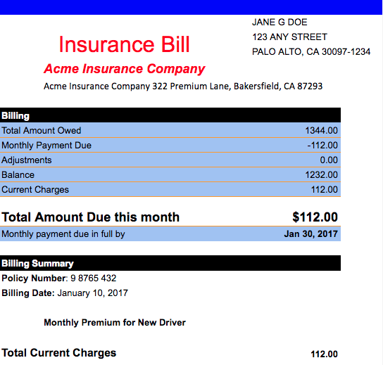

- Which option did you choose for this bill: single or monthly? Explain your reasoning.
Monthly option
- It’s an annual policy with fixed monthly payments of $112, so there won’t be variability month to month.
- This is an important expense, so you don’t want to risk forgetting to pay this bill by selecting “single”.

- Look at the due date on the bill above. When do you think you need to send this payment in order for your payment to be on time? Explain.
According to the bill, the monthly payment is due by January 30, 2017. Students noticed with the first bill that payments take 4-6 business days to process. If there is a weekend involved, then students may need to add 2 more days.

Students would need to send the payment up to 8 days prior to January 30th for the bill to reach on time.

**Head back to your slides now**

Part III: Examine Your Checking Account Activity
Follow the directions for Step 8 on the slides.

- List two ways you were able to use the money in your checking account in January.
- Students used their debit cards to purchase items from Cool Snacks, Movie Card, Cafe Club and Clothing Rack.
- They also withdrew $30 from an out-of-network ATM which led to a $3 fee.
- They also did mobile shopping from their phone.

- How much money did you start January with?
Opened account on January 1st with $250.00

- How much money did you end January with?
$79.62

- Did your Checking Account increase or decrease in value? By how much?
Decreased by $170.38

- Calculate the total amount added to your account in January (NOT including your initial deposit).
Paycheck on 1/1 ($75) and 1/15 ($75) for a total of $150.

- List at least three transactions that reduced the value of your Checking Account.
Transactions that reduced value of Checking Account:
- Cool Snacks
- Movie Card
- Cafe Club
- Clothing Rack
- Mobile Shopping
- ATM Withdrawal
- Fees
Extension: Have students calculate totals for each of these categories and sort from highest to lowest to figure out where majority of spending is coming from.

- After reviewing your January account, why should you be concerned about your spending patterns going forward?
If students continue to spend money at the same rate they did in January, they will run out of money (and be charged overdraft fees) very quickly! It is necessary that students reevaluate their spending habits to make sure that they are not overspending.

- Name at least two steps that you can take so that your money lasts longer.
Answers might include:
- Reduce unnecessary spending
- Work more hours to increase paychecks going into checking account
- Biggest expenses are cell phone and car insurance: Are you willing to give those up?

**Head back to your slides now**

Part IV: Examine Your Savings Account Activity
Follow the directions for Step 9 on the slides.

- How much money did you start January with?
$250 deposited on January 1st

- How much money did you end January with?
$250.21

- Did your Savings Account increase or decrease in value? By how much?
Increased by $0.21

- In looking at your Savings Account activity, what do you notice was added to your account? Explain what happened.
The bank paid $0.21 in interest for the amount held by the student in the Savings Account.

Note: It is important to explain that amounts in Savings accounts earn interest (very low today) while those in Checking accounts usually do not.

- Your teacher mentioned to you that saving can be really difficult and you should make it as automatic as possible. What’s a strategy that you could use with your paycheck to make your savings more automatic?
When direct depositing a paycheck, split it between your savings and checking account and try to only spend from your checking account. OR set regular transfers out of your checking into your savings immediately after getting paid. BUT beware that, as seen above, you’re already spending more than you’re putting into your checking account, so without a better budget, diverting money into savings will cause you to overdraw your checking even sooner/more often.

**Head back to your slides now**

Part V: Review Your Monthly Statements
Follow the directions for Step 10 on the slides.

- Review the Monthly Statement online. What day of the month are your Account Statements available?
3rd day after the end of the month, so January’s statement will be available on February 3rd.

- You’ll notice that your TOTAL DEBITS = $320.28 and your TOTAL CREDITS = $400. What do these mean?
TOTAL DEBITS = all of the money that WENT OUT of your account. These were your expenses in the month of January, 2017.

TOTAL CREDITS = all of the money that CAME INTO your account. This includes the initial $250 you deposited into your account on January 1st (notice that the Opening Balance = $0 because you opened your account that month) and the $150 you received from your two paychecks.

- Did you pay any fees in January? Explain.
Yes. Out-of-network ATM fee of $3.00

**Head back to your slides now**

Part VI: Mobile Deposits
Follow the directions for Steps 11 and 12 on the slides.
- When you click the UPLOAD button, a check appears that has numbers that correspond to information that you enter into a check. Match up these items with where they would appear on the check:

$50 | Bobby Jones’ signature | Your Name | fifty dollars and 00XXX | House and dog-sitting | February 1st, 2017

1 | February 1st, 2017
2 | Your Name
3 | $50
4 | fifty dollars and 00XXX
5 | House and dog-sitting
6 | Bobby Jones’ signature

**Head back to your slides now**

- What date did you deposit the check?
Simulator date was February 3rd when the check was deposited.

- What date did the check appear in your ACCOUNT ACTIVITY?
February 7th is the date the check appears in Account Activity for checking account. This shows how there is a lag between the date the check is deposited and when it actually “hits” one’s account.

**Head back to your slides now**

Part VII: Set Up Alerts
Follow the directions for Step 14 on the slides.
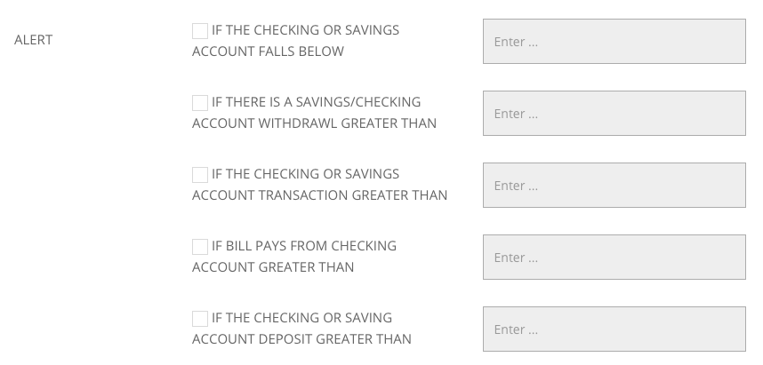

- Why are alerts important? What would happen to your account if you spent more than you had in your account?
Alerts are important because they can notify you when your balance is running below a certain amount. This can help you prevent paying any overdraft fees (especially since you accepted overdraft coverage in the beginning of this simulation when you opened your account!).

- Which of the five alerts do you think is most important for you? Explain.
[Answers will vary]

- What did you set as the dollar amount that would trigger an alert for the most important alert you identified in the previous question? Explain your answer.
[Answers will vary] Answers should include knowledge of typical purchase patternsthat’s s

**Head back to your slides now**

Part VIII: Transfer Money Between Accounts
Follow the directions for Step 15 on the slides.

- Do you think this transfer is a good idea? Explain.
Answers will vary. Answers should include a recognition that this is not a good long-term strategy since spending down your Checking Account (the student is spending more than their paychecks every month) and covering it with transfers from your Savings Account is symptomatic of a larger issue.

**Head back to your slides now**

Part IX: Online Account Notifications
Follow the directions for Step 16 on the slides.

- Recall the alerts that you set up in Part VII. When did you start receiving these notifications? What were the notifications telling you?
Answers will vary based on actions taken in Part VII.

- What steps should you have taken when you first started receiving these notifications?
Answers will vary. Steps might include:
- Working more hours to increase money going into the checking account
- Looking for ways to reduce spending (wants vs. needs conversation)
- Transfer money from Savings Account to Checking Account

**Head back to your slides now**

Part X: Manage Your Checking Account So It Does Not Manage You
Follow the directions for Step 17 on the slides.

On what date did your Checking Account first go negative? What caused this to happen?
March 1st when you purchased items at Cool Snacks for $10.35 and only had $9.24 in your account.

- What happens when your Checking Account goes negative? Review the ACCOUNT ACTIVITY to come up with an answer.
You are charged overdraft fees ($34) for every purchase that you make when your account is negative.

- When you originally signed up for your account, you opted in to Overdraft Protection. Describe how the details of your Account Activity would have changed if you had NOT signed up for Overdraft Protection.
You would not have been able to complete the transactions if you didn’t have the money in your account to cover them. You also would not have been charged any overdraft fees.
- Teacher Tip: This could be a good time to ask students, “Is it possible to opt-out of overdraft protection even after you’ve signed up for it?” The answer is YES!

- You have now seen several months of Checking and Savings Account activity. What changes do you want to make to your budget and account preferences to avoid all those pesky fees?
Answers will vary.

**Head back to your slides now**

Part XI: You Made It! What Did You Learn?
Follow the directions for Step 18 on the slides.

- List at least 3 things you learned from this simulation that you can use to manage your own online bank accounts.
Answers will vary.

Teachers, below are screenshots of the final Checking Account transactions that students should end up.